Web Application
HTML is used for creating only static web pages (WEB SITES). But it is not enough for developing web application to perform business processes and data storage, retrieval operation from Data base Server.
Scripting Languages
- Client Side
- Server Side
What is Servlet?
A Servlet is a server side scripting language for developing web components in J2EE. This is for receiving the request from user and process it and giving response back to user.
A Servlet is a Java programming language class that is used to extend the capabilities of servers that host applications access via a request-response programming model. Although Servlets can respond to any type of request, they are commonly used to extend the applications hosted by web servers. For such applications, Java Servlet technology defines HTTP-specific Servlet classes.
Why Servlet?
- Read any data sent by the user.
- Look up any other information about the request that is embedded in the HTTP request.
- Generate the results.
- Format the results inside a document.
- Set the appropriate HTTP response parameters.
- Send the document back to the client.

The Advantages of Servlets Over “Traditional” CGI
- Efficient
- Convenient
- Powerful
- Portable
- Secure
- Inexpensive

Servlet API and Web Container
Servlet API is for Creating Web components
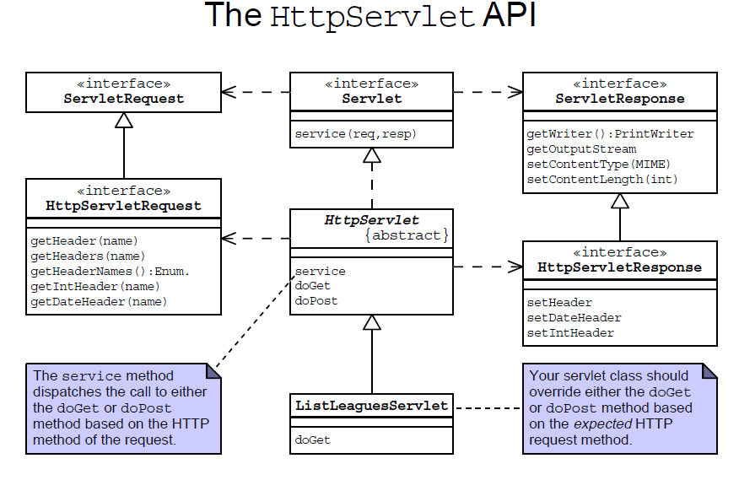

Web Container
Web Container is for running the web components.
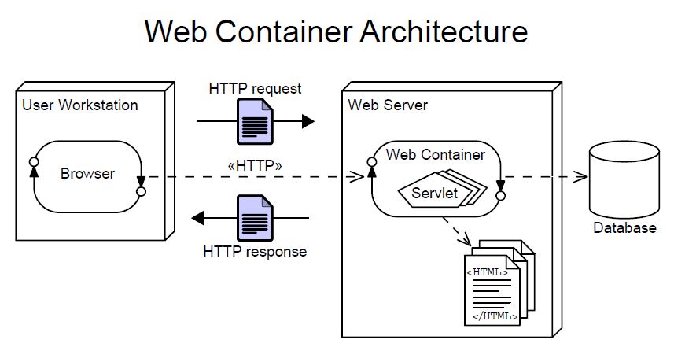

Web container is a special JVM to run web components.
What does it (Container) give?
- Communication Support
- Life cycle management
- Multithreaded Support
- Declarative Security
- Jsp Support

HttpServletResponse – program can write the response in this object sent it back to the browser.
PrintWriter out = resp.getWriter();
response.setContentType("text/html");
out.println("information");

Web Component or Sevlet Program
Creating FirstServlet.java
package com.first;
import java.io.IOException;
import java.io.PrintWriter;
import java.util.Date;
import javax.servlet.ServletException;
import javax.servlet.http.HttpServlet;
import javax.servlet.http.HttpServletRequest;
import javax.servlet.http.HttpServletResponse;
public class FirstServlet extends HttpServlet {
static int count;
protected void doGet(HttpServletRequest req, HttpServletResponse resp)
throws ServletException, IOException {
PrintWriter out = resp.getWriter();
out.println("<html>");
out.println("<head>");
out.println("<title>My First Servlet Page</title>");
out.println("</head>");
out.println("<body>");
out.println("Servlet Time is " + new Date());
out.println("Page has been visited for " + (++count));
out.println("</body>");
out.println("</html>");
}
}

Configure the Web Component in the Deployment Descriptor file
Creating web.xml file
<web-app
xmlns:xsi="http://www.w3.org/2001/XMLSchema-instance"
xmlns="http://java.sun.com/xml/ns/javaee"
xmlns:web="http://java.sun.com/xml/ns/javaee/web-app_2_5.xsd"
xsi:schemaLocation="http://java.sun.com/xml/ns/javaee
http://java.sun.com/xml/ns/javaee/web-app_2_5.xsd"
id="WebApp_ID" version="2.5">
<servlet>
<servlet-name>first</servlet-name>
<servlet-class>com.first.FirstServlet</servlet-class>
</servlet>

<servlet-mapping>
<servlet-name>first</servlet-name>
<url-pattern>/mypage</url-pattern>
</servlet-mapping>

</web-app>

Deploying Web Application
File Structure of Tomcat server (Deploy the Web Component)
Root Folder of the Web Applications
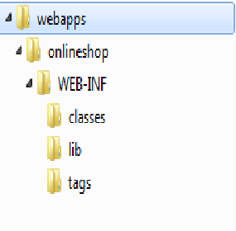
Web.xml
My Application Name (Context Path)
Put all web pages and related items in this folder or in the sub folders (html, Jsp, images, js, css)
Put all Java file here
Put jar files here (lib)

Put all the tld and tag files here

Deployment Descriptor

Mapping between Eclipse Development Environment and Tomcat Deployment structure
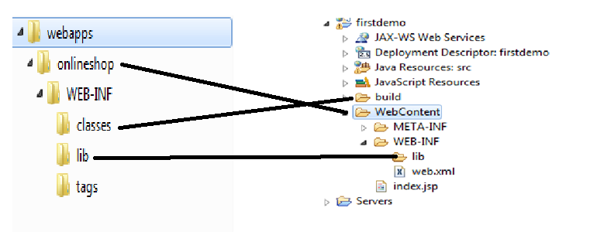
Make the request to below url address and see the output
http://localhost:8080/onlineshop/mypage

How Servlet is working
- Request hits the web server
- Server Create an HttpRequest and HttpResponse Object
- Server pass the request to web container
- Container create a Thread object
- Web container consulting with web.xml
- If the Servlet is found
- Current thread of the request is calling the service method of that servlet and passing request and response to the method.
- Service method is checking that what type of request and calling the corresponding method of your servlet program.
- doGet or doPost method is executed
- After servlet method executed then it return response to web container.
- Container passes the request to server and server passes the request to browser.
- Destroy request and response and thread object of the user request.
- if the servlet is not found send 404 error to user

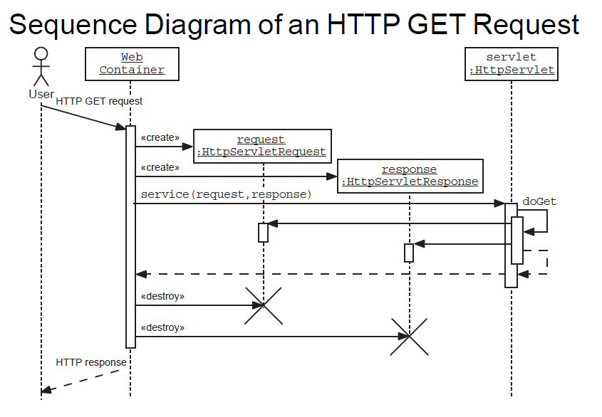

How Server processing Multiple Request
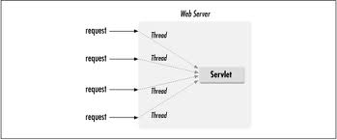
Servlet Life Cycle
Web Container is creating object of a servlet classes only one time when servlet is requested for the first time.
If an instance of the servlet does not exist, the web container
- Load the Class file to Web Container
- Creating Instance of the Servlet
- Calling Construcor of the Servet
- Calling init() method of the object only one time before processing any request
- Calling service method whenever request is received
- Calling Destroy() method when the server is shutdown

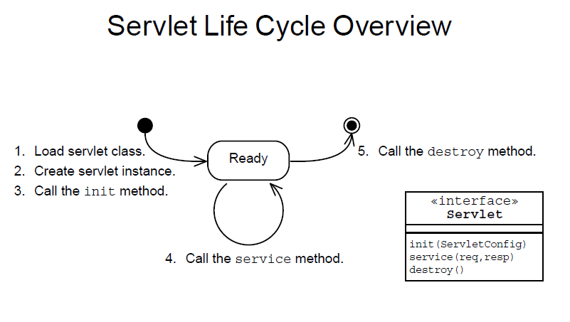
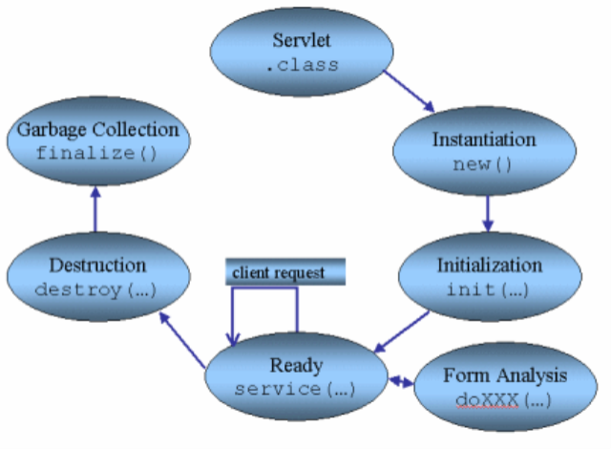
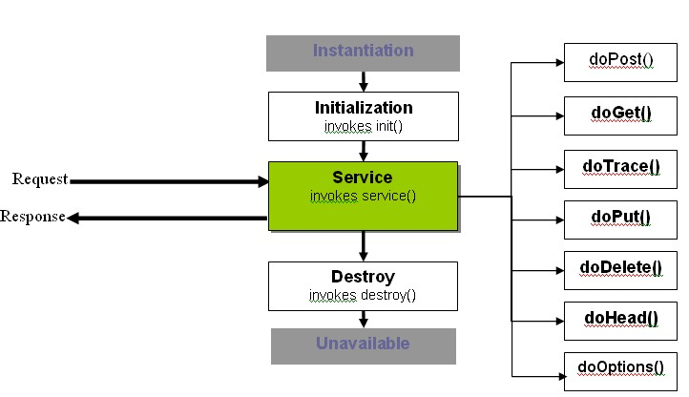

Binary Response to User
@Override
protected void doGet(HttpServletRequest req, HttpServletResponse resp)
throws ServletException, IOException {
resp.setContentType("application/jar");
ServletContext context=getServletContext();
InputStream is=context.getResourceAsStream("/jdbc.jar");
int read=0;
byte[] raw=new byte[1024];
OutputStream out=resp.getOutputStream();
while((read=is.read(raw))!= -1){
out.write(raw,0,read);
}
out.flush();
out.close();
}

Servlet API
Interfaces in javax.servlet package

There are many interfaces in javax.servlet package.

They are as follows:
- Servlet
- ServletRequest
- ServletResponse
- RequestDispatcher
- ServletConfig
- ServletContext
- SingleThreadModel
- Filter
- FilterConfig
- FilterChain
- ServletRequestListener
- ServletRequestAttributeListener
- ServletContextListener
- ServletContextAttributeListener

Classes in javax.servlet package
There are many classes in javax.servlet package.
They are as follows:
- GenericServlet
- ServletInputStream
- ServletOutputStream
- ServletRequestWrapper
- ServletResponseWrapper
- ServletRequestEvent
- ServletContextEvent
- ServletRequestAttributeEvent
- ServletContextAttributeEvent
- ServletException
- UnavailableException

Interfaces in javax.servlet.http package
There are many interfaces in javax.servlet.http package.
They are as follows:
- HttpServletRequest
- HttpServletResponse
- HttpSession
- HttpSessionListener
- HttpSessionAttributeListener
- HttpSessionBindingListener
- HttpSessionActivationListener
- HttpSessionContext (deprecated now)

Classes in javax.servlet.http package
There are many classes in javax.servlet.http package.
They are as follows:
- HttpServlet
- Cookie
- HttpServletRequestWrapper
- HttpServletResponseWrapper
- HttpSessionEvent
- HttpSessionBindingEvent
- HttpUtils (deprecated now)

